Galactic Conquests: Planet Ownership

NB: “Pirate” is a catch all term for indigenous, non-allied forces.

The Old Republic Era

The Jedi Civil War (3959 – 3956 BBY) (39 planets)

Sith Worlds (8)

Korriban (capital)
Bonadan
Honoghr
Hypori
Ryloth
Kessel
Saleucami
Rakata Prime (Star Forge)

Republic Worlds (23)

Coruscant (capital)
Anaxes
Fresia
Corulag
Carida
Alderaan
Kuat
Corellia
Manaan
Bothawui
Abregado Rae
Fondor
Thyferra
Bestine
Atzerri
Mechis III
Taris
Brentaal
Onderon
Sullust
Dantooine
Tatooine
Mon Calamari

Pirate Worlds (8)

Mandalore
Felucia
Dxun
Trandosha
Kashyyyk
Hapes
Nal Hutta
Naboo

The Great War (3681 – 3653 BBY) (38 planets)

Sith Worlds (7)

Korriban (capital)
Bonadan
Honoghr
Hypori
Ryloth
Kessel
Saleucami

Republic Worlds (24)

Coruscant (capital)
Anaxes
Fresia
Corulag
Carida
Alderaan
Kuat
Corellia
Manaan
Bothawui
Abregado Rae
Fondor
Thyferra
Bestine
Atzerri
Mechis III
Taris
Brentaal
Onderon
Sullust
Dantooine
Tatooine
Mon Calamari
Naboo

Pirate Worlds (7)

Mandalore
Felucia
Dxun
Trandosha
Kashyyyk
Hapes
Nal Hutta

The New Sith Wars (2000 – 1000 BBY) (47 planets)

Sith Worlds (13)

Korriban (capital)
Bonadan
Honoghr
Hypori
Ryloth
Kessel
Saleucami
Yavin
Polus
Lok
Muunilinst
Dathomir
Hoth

Republic Worlds (24)

Coruscant (capital)
Anaxes
Fresia
Corulag
Carida
Alderaan
Kuat
Corellia
Manaan
Bothawui
Abregado Rae
Fondor
Thyferra
Bestine
Atzerri
Mechis III
Taris
Brentaal
Onderon
Sullust
Dantooine
Mon Calamari
Naboo
Jabiim

Pirate Worlds (10)

Mandalore
Felucia
Dxun
Trandosha
Kashyyyk
Hapes
Nal Hutta
Tatooine
Utapau
Bespin

The Fall of the Republic/Rise of the Empire

The Clone Wars (22 – 19 BBY) (64 planets)

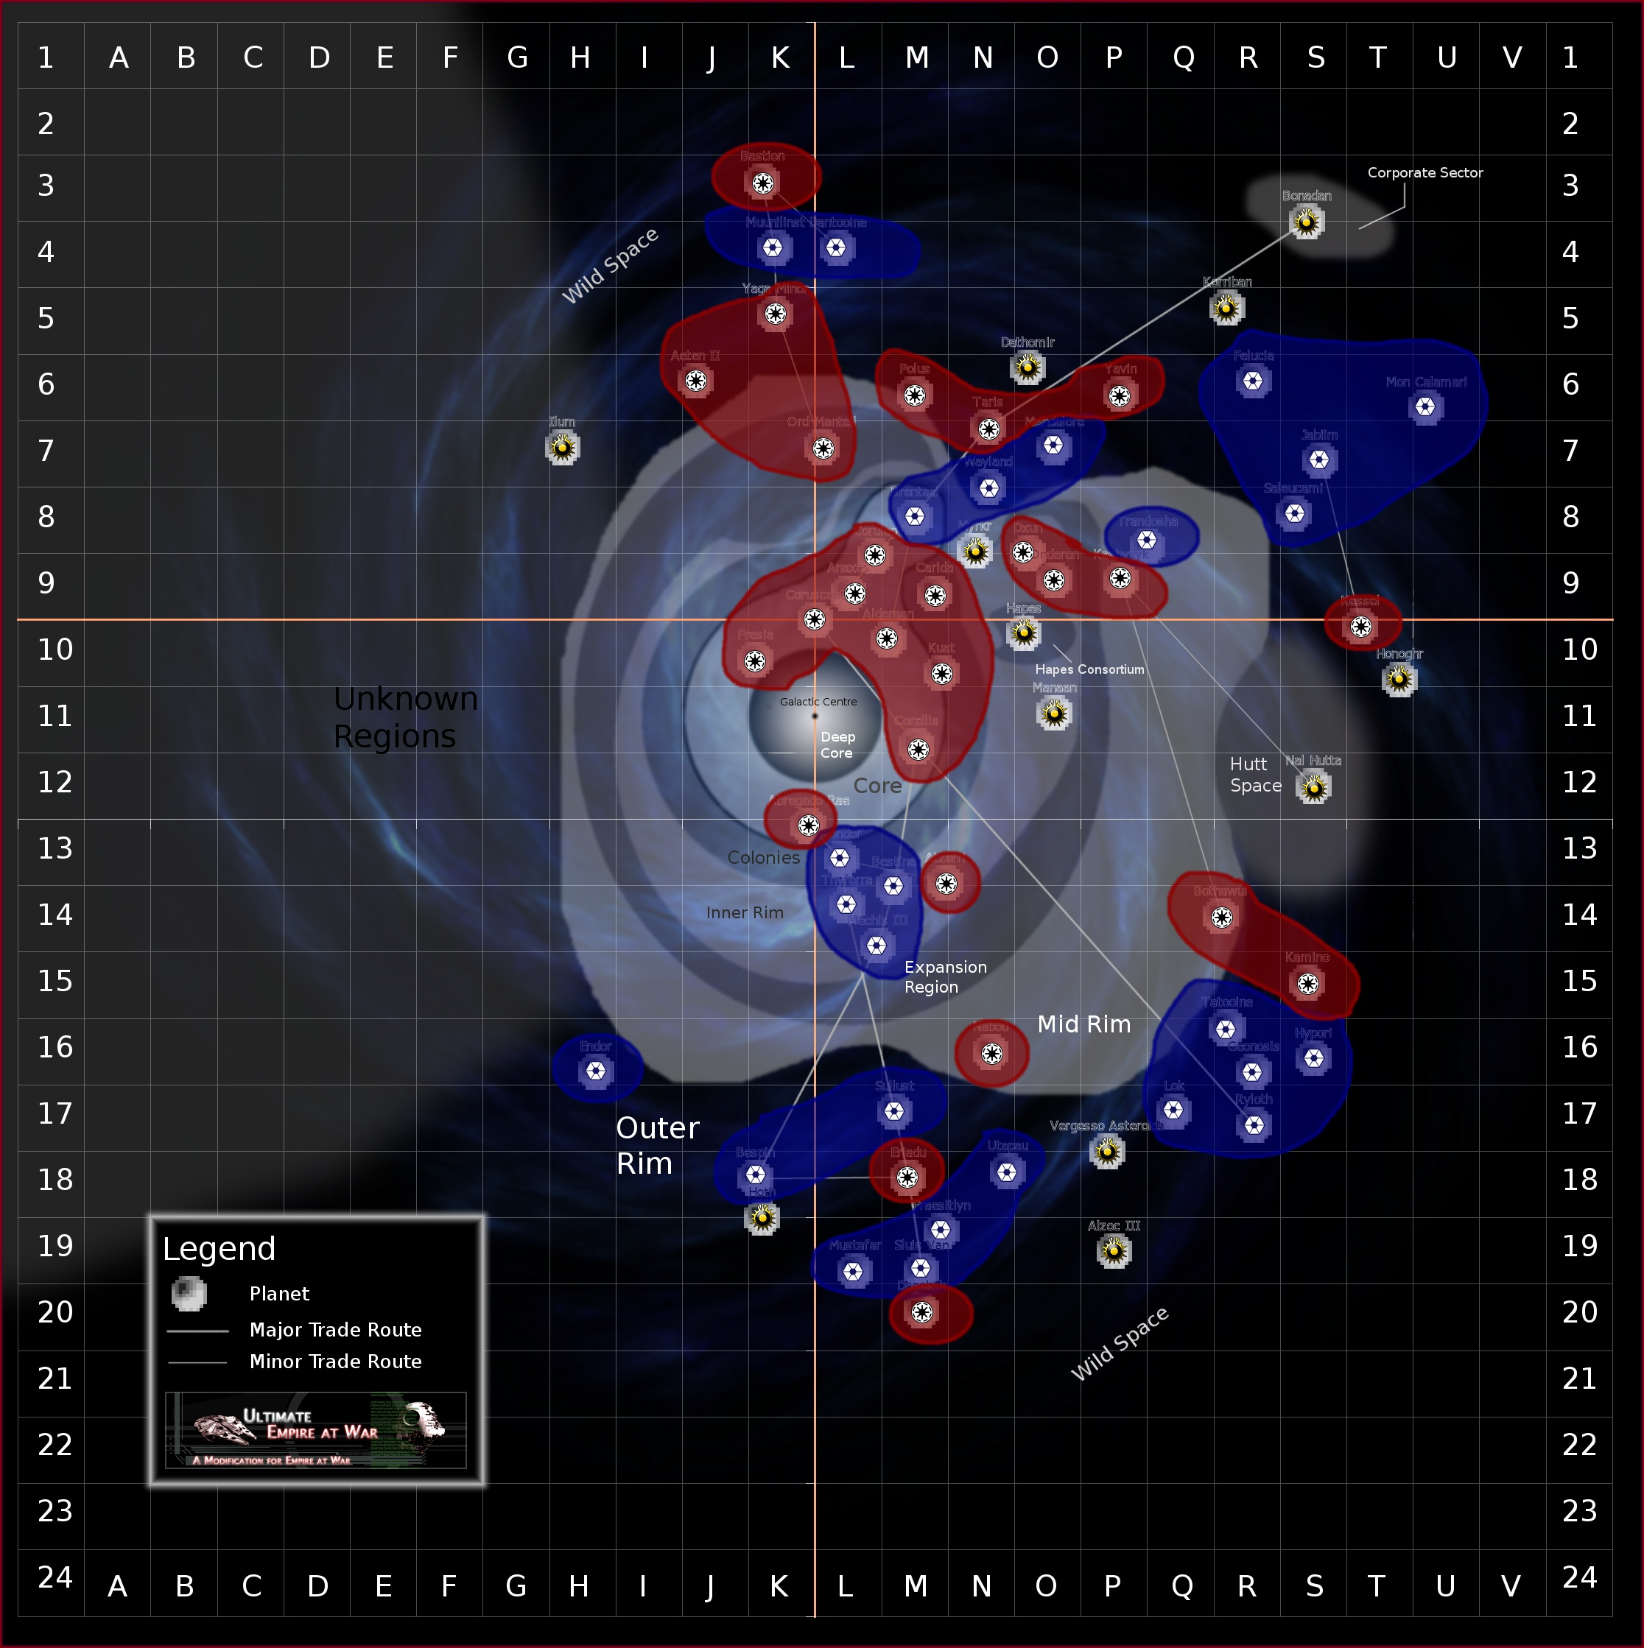

CIS Worlds (26)

Bespin
Bestine
Brentaal
Dantooine
Endor
Felucia
Fondor
Geonosis
Hypori
Jabiim
Lok
Mandalore
Mechis III
Mon Calamari
Mustafar
Muunilinst
Praesitlyn
Ryloth
Saleucami
Sluis Van
Sullust
Tatooine
Thyferra
Trandosha
Utapau
Wayland

Republic Worlds (26)

Abregado Rae
Aeten II
Alderaan
Anaxes
Atzerri
Bastion
Bothawui
Carida
Corellia
Corulag
Coruscant (capital)
Dagobah
Dxun
Eriadu
Fresia
Kamino
Kashyyyk
Kessel
Kuat
Naboo
Ord Mantell
Onderon
Polus
Taris
Yaga Minor
Yavin

Pirate Worlds (12)

Alzoc III
Bonadan
Dathomir
Hapes
Honoghr
Hoth
Ilum
Korriban
Manaan
Myrkr
Nal Hutta
Vergesso Asteroids

The Clone Wars: Outer Rim Sieges (22 – 19 BBY) (45 planets)

CIS Worlds (21)

Bespin
Dantooine
Endor
Felucia
Geonosis
Hypori
Jabiim
Lok
Mandalore
Mon Calamari
Mustafar
Muunilinst
Praesitlyn
Ryloth
Saleucami
Sluis Van
Sullust
Tatooine
Trandosha
Utapau
Wayland

Republic Worlds (15)

Abregado Rae
Aeten II
Bastion
Bothawui
Dagobah
Eriadu
Kamino
Kashyyyk
Kessel
Naboo
Ord Mantell
Polus
Taris
Yaga Minor
Yavin

Pirate Worlds (9)

Alzoc III
Bonadan
Dathomir
Honoghr
Hoth
Ilum
Korriban
Nal Hutta
Vergesso Asteroids

The Galactic Civil War

Empire At War (2BBY – 4ABY) (67 planets)

Rebel Alliance Worlds (21)

Abregado Rae
Alderaan
Bothawui
Dagobah
Dantooine
Felucia
Geonosis
Hoth
Ilum
Kamino
Kashyyyk
Mon Calamari
Mustafar
Naboo
Polus
Ryloth
Shola
Sullust
Tatooine
Thyferra
Utapau
Yavin

Imperial Worlds (38)

Aeten II
Alzoc III
Anaxes
Atzerri
Bastion
Bespin
Bestine
Brentaal
Byss
Carida
Corellia
Corulag
Coruscant (capital)
Dathomir
Dxun
Ebaq IX
Endor
Eriadu
Fondor
Fresia
Jabiim
Kessel
Kuat
Lok
Mandalore
Mechis III
Muunilinst
Myrkr
Ord Mantell
Onderon
Praesitlyn
Saleucami
Sluis Van
Taris
The Maw
Trandosha
Wayland
Yaga Minor

Pirate Worlds (8)

Bonadan
Hapes
Honoghr
Hypori
Korriban
Manaan
Nal Hutta
Vergesso Asteroids

The New Republic Era Galactic Civil War

Purge of the Imperials (4ABY – 9ABY) (54 planets)

New Republic Worlds (24)

Abregado Rae
Alderaan [graveyard]
Alzoc III
Atzerri
Bespin
Bestine
Bothawui
Corulag
Dantooine
Endor
Felucia
Fondor
Geonosis
Kashyyyk
Mon Calamari
Naboo
Onderon
Polus
Ryloth
Sluis Van
Sullust
Tatooine
Thyferra

Imperial Remnant Worlds (22)

Aeten II
Anaxes
Bastion
Brentaal
Byss
Carida
Corellia
Coruscant (capital)
Eriadu
Fresia
Honoghr
Hoth
Jabiim
Kessel
Korriban
Kuat
Muunilinst
Ord Mantell
Praesitlyn
The Maw
Wayland
Yaga Minor

Pirate Worlds (8)

Bonadan
Hapes
Hypori
Mechis III
Nal Hutta
Saleucami
Taris
Vergesso Asteroids

Thrawn Campaign (9ABY – 10ABY) (34 planets)

New Republic Worlds (15)

Anaxes
Bothawui
Carida
Corellia
Corulag
Coruscant (capital)
Dagobah
Dantooine
Fondor
Kashyyyk
Mon Calamari
Mustafar
Sluis Van
Sullust
Thyferra

Imperial Remnant Worlds (14)

Bastion
Bestine
Byss
Eriadu
Honoghr
Jabiim
Kessel
Kuat
Mechis III
Muunilinst
Praesitlyn
Saleucami
The Maw
Yaga Minor

Pirate Worlds (5)

Bonadan
Corellia
Nal Hutta
Ord Mantell
Taris

